Evidence Independence Specification (EIS): Foundational Peer-Review Report and Mathematical Assessment
Document Type: Foundational Scientific Peer-Review Report
Subject: Evidence Independence Specification (EIS)
Version Assessed: EIS v1.0 and Associated Theoretical/Empirical Framework
Classification: Academic/Institutional Assessment
Recommended Provision: Promising Foundational Framework — Major Revision

Executive Assessment and Epistemic Taxonomy
The Evidence Independence Specification (EIS) addresses a foundational vulnerability in automated evidence aggregation: the unwarranted assumption that multiple observations represent distinct, statistically independent sources of information. While the existence of statistical correlation and redundant data is well established across signal processing and evidence theory, the primary contribution of the EIS lies in its operational architecture. It establishes a formal pipeline for quantifying structural redundancy among evidence sources via provenance embeddings, spectral linear algebra, and graph topology, subsequently propagating these measurements directly into Bayesian trust updating and confidence calculations¹.
The underlying mathematical tools utilized within the EIS—including positive-semidefinite reproducing kernels, participation-ratio effective ranks, graph Laplacians, and Bayesian update mechanics—are mathematically rigorous and established¹. However, the synthesis of these distinct tools into a unified specification for evidence independence represents a prospective framework requiring systematic empirical validation. A critical finding of this assessment is that the structural independence metric derived by the EIS must not be described as a universal measure of probabilistic statistical independence. Rather, the strongest scientifically defensible formulation supported by current evidence is that the EIS provides a kernel- and provenance-dependent measure of effective evidentiary dimensionality.
To maintain scientific rigor, this assessment evaluates the EIS across four distinct epistemic levels, ensuring mathematical correctness is strictly segregated from modeling assumptions and operational outcomes.

Epistemic Level | Definition and Criteria | Current Assessment Status
Mathematical | Results that follow strictly from stated definitions, linear algebra, and functional analysis. | Fully Validated (Gram PSD, Cauchy-Schwarz bounds 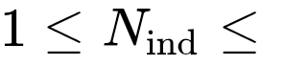).
Theoretical | Hypotheses supported by sound mathematical arguments but dependent on domain-specific modeling assumptions. | Defensible (Spectral rank as proxy for evidentiary capacity; Bayesian discounting).
Empirical | Assertions corroborated by reproducible computational, synthetic, or experimental evidence. | Partially Corroborated (Diffusion vs. wave dynamics; baseline spectral behavior)⁶.
Operational | Efficacy and performance metrics demonstrated within complex real-world institutional environments. | Unproven (Strategic objectives such as 40% false-positive reduction remain unverified).

Formal Problem Statement and Scientific Motivation
In standard inference and decision-engine architectures, an aggregation module receives an evidence set comprising  observations, denoted as 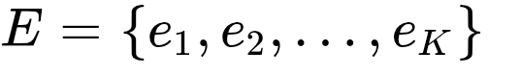. Naïve aggregation algorithms proceed under the implicit assumption of conditional independence among observations given a hypothesis , yielding a joint likelihood product:
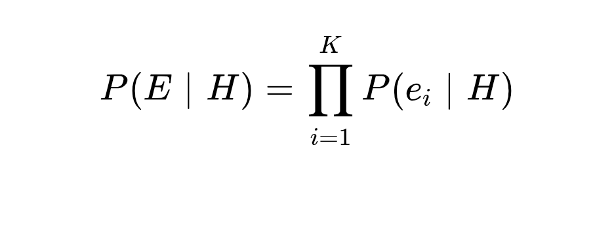
Under true conditional independence, this formulation is mathematically justified and maximizes statistical power. However, in realistic operational environments, evidence sources frequently share underlying physical sensors, computational model weights, common upstream databases, lineage pipelines, or coordinated adversarial origins². In such scenarios, the count of raw observations systematically exceeds the count of independent information sources:

When a naïve aggregation procedure treats dependent corroboration as independent proof, the posterior probability 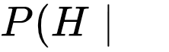 suffers from confidence inflation². The system accumulates redundant mathematical weight for a single underlying factual signal, leading to severe operational failures such as automated false-alarm cascades, vulnerability to strategic source duplication, and distorted risk scoring². The EIS addresses this issue by constructing a mathematically formal, provenance-aware interface that discounts structural redundancy prior to probabilistic updating.

Mathematical Architecture of the EIS

+-------------------------------------------------------+
| Provenance Embedding Space (\phi_i \in \mathcal{H}) |
+-------------------------------------------------------+
|
v
+-------------------------------------------------------+
| Kernel Geometry Matrix (G_ij = exp(-\gamma||\phi||^2)) |
+-------------------------------------------------------+
|
v
+-------------------------------------------------------+
| Spectral Analysis & Effective Rank (N_ind, s_ind) |
+-------------------------------------------------------+
|
v
+-------------------------------------------------------+
| Graph & Dynamic Extensions (L = D - A, N_ind(t)) |
+-------------------------------------------------------+
|
v
+-------------------------------------------------------+
| Likelihood Weighting & Bayesian Trust Updating |
+-------------------------------------------------------+

Provenance Representation and Space Geometry
The EIS maps each evidence source 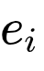 into a continuous Hilbert space 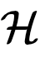 via a specialized provenance embedding function:

The embedding vector 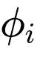 encapsulates structural metadata surrounding the origin and transmission of evidence. Key metadata dimensions encoded within include:
- Physical and spatial origin coordinates
- Computational lineage and hardware identifiers
- Algorithmic model architecture and training dataset lineage
- Temporal timestamps and acquisition mechanisms
- Common upstream network hops or database dependencies
- Transformation history and semantic feature embeddings
This representation implies an foundational constraint: EIS independence measurements are strictly relative to the expressive capacity and fidelity of the provenance representation . If two distinct evidence streams originate from a shared latent compromise but their metadata profiles are identical across all dimensions encoded by , the geometric distance 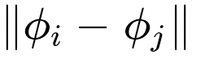 will vanish, and the system will evaluate them as structurally redundant. Conversely, if fails to capture a shared upstream dependency, EIS cannot infer an independence deficit that is absent from the underlying feature space. The provenance mapping is therefore a core component of the scientific specification.

Kernel Construction and Sensitivity Analysis
Pairwise structural similarity across the provenance embeddings is computed using a Radial Basis Function (RBF) kernel, constructing a Gram matrix 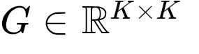:
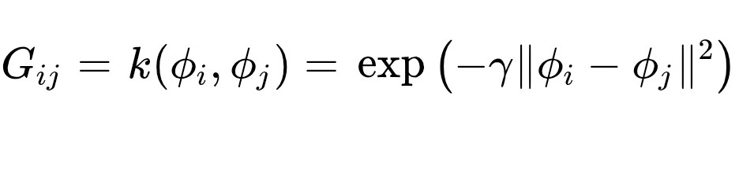
where 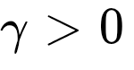 represents the kernel bandwidth hyperparameter. Because the RBF kernel is Mercer-kernel compliant, the resulting Gram matrix  is real, symmetric, and positive semidefinite (PSD):
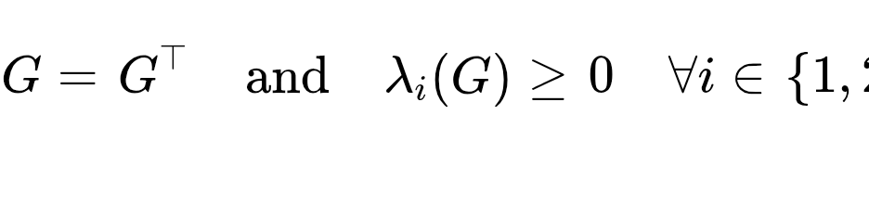
The non-negativity of the spectrum 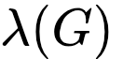it is a prerequisite for the subsequent spectral rank formulations. The parameter governors the sensitivity threshold of the geometry. The operational impact of is summarized below:
Bandwidth Regime | Geometric Behavior | Spectral Mass Distribution | Implied Independence
Under-smoothed (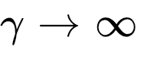) | Off-diagonal entries 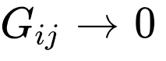; 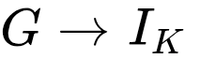. | equal eigenvalues 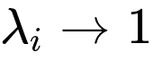. | Every distinct source is evaluated as perfectly independent ().
Over-smoothed (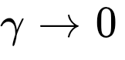) | All entries 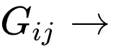; 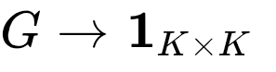. | Single dominant eigenvalue 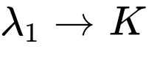; others 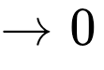. | All sources are evaluated as completely redundant (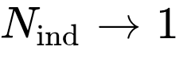).
Optimal Calibrated () | Off-diagonals reflect true structural overlap in . | Eigenvalues decay smoothly according to cluster topology. | Effective rank tracks true underlying latent dimensionality.
Because an arbitrary selection of can manipulate the reported independence metric across its entire theoretical range, systematic sensitivity analysis of 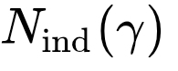must be established as a mandatory benchmarking requirement for all operational EIS deployments.

Spectral Effective Rank and Dimensionality Bounds
To extract a continuous measurement of effective independent information channels from the Gram matrix spectrum, the EIS uses a participation-ratio effective rank functional¹:
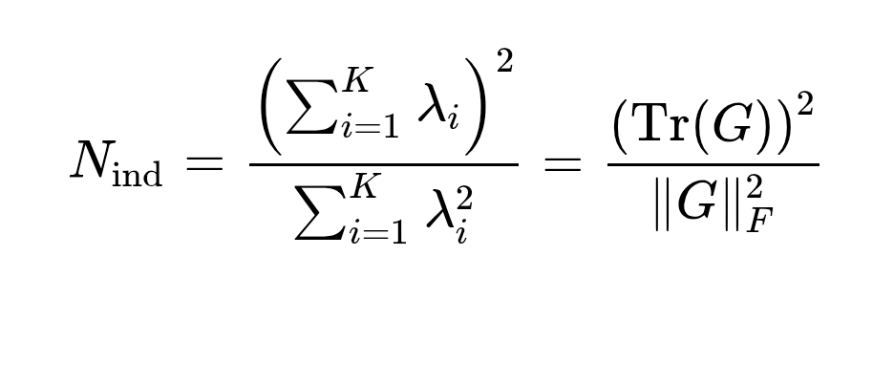
where 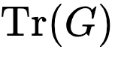 is the matrix trace and 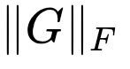 is the Frobenius norm. Because 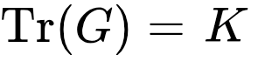 when 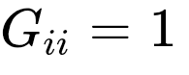, this expression simplifies to 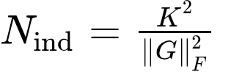, allowing efficient computation without explicit full eigendecomposition¹⁰.
The statistic 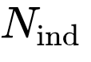 satisfies strict mathematical bounds, expressed as the foundational theorem of EIS spectral geometry:

The formal proof relies on standard linear algebra inequality constraints:
- Upper Bound Proof: By applying the Cauchy-Schwarz inequality to the eigenvalue vector 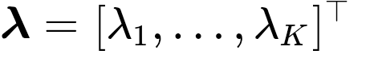 and the ones vector 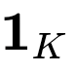:
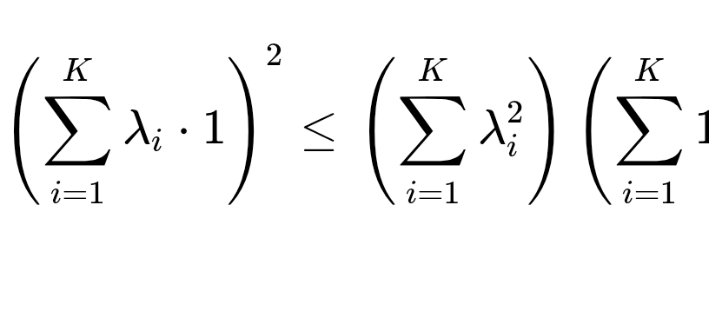
Dividing both sides by 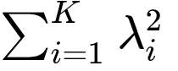 yields . Equality holds if and only if all eigenvalues are identical (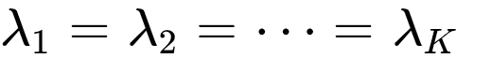), representing a state of uniform spectral distribution where all sources are mutually orthogonal in the feature space.
- Lower Bound Proof: Expanding the squared sum of non-negative eigenvalues (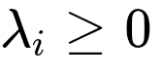):
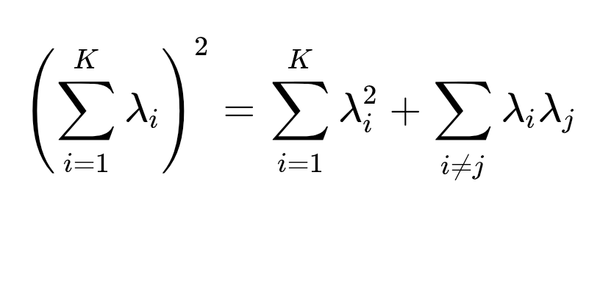
Since 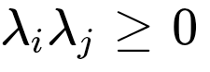 for all pairs, it follows directly that 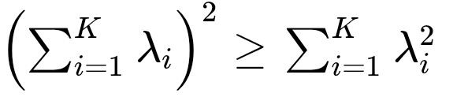, establishing 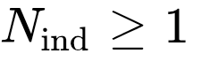. Equality holds if and only if exactly one eigenvalue is non-zero (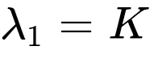, 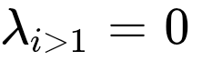), indicating that all evidence observations are linear duplicates residing within a single subspace dimension.
To establish a scale-invariant metric suitable for operational decision thresholds, the EIS defines the Normalized Spectral Independence Score  for 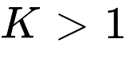:
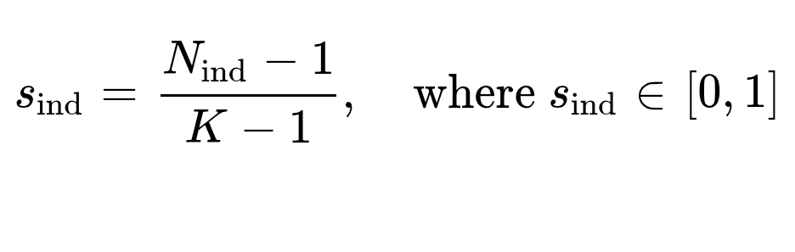
A value of 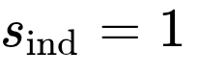 denotes complete structural independence across the evidence set, whereas 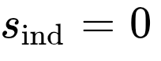 indicates total structural redundancy.

Positioning Relative to Established Mathematical Frameworks
The EIS operates at the convergence of several linear algebra, information theory, and kernel dependency frameworks¹. To clarify its scientific novelty, the EIS must be formally distinguished from alternative formulations.

+-----------------------------------------------------------------------------------+
| Information & Independence Measures |
+------------------------------------+----------------------------------------------+
| Pairwise / Bivariate Dependence | Aggregate Dimensionality & Redundancy |
| - HSIC (Gretton et al.) | - Classical Matrix Rank (Algebraic Span) |
| - Mutual Information I(X;Y) | - Shannon Entropy H(P) / Rényi Entropy |
| - Distance Correlation | - EIS Effective Rank N_ind (Spectral Mass) |
+------------------------------------+----------------------------------------------+

Metric / Framework | Core Mathematical Formulation | Conceptual Scope | EIS Functional Difference
Classical Matrix Rank |  | Counts non-zero dimensions; discontinuous and unstable under numerical noise¹⁰. | EIS provides a continuous, smooth measure of active spectral mass sensitive to relative magnitude¹⁰.
Hilbert-Schmidt Independence Criterion (HSIC) | [cite: 4, 11] | Measures statistical dependence between two random variables in RKHS⁴. | HSIC answers a binary hypothesis question ("Are  and  dependent?")⁴. EIS quantifies aggregate dimensional capacity across evidence streams.
Shannon Spectral Entropy | , where 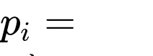  [cite: 10] | Logarithmic entropy of normalized eigenvalue probability distribution¹⁰. | Spectral entropy uses a logarithmic functional; EIS uses a quadratic participation ratio, avoiding 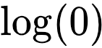 instabilities¹⁰.
EIS Participation Ratio | 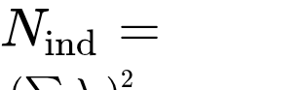  [cite: 1, 9] | Measures effective dimensionality over a provenance similarity Gram matrix¹. | Unifies provenance geometry with continuous linear rank to adjust Bayesian update weights directly³.

Topological, Temporal, and Inferential Extensions

Graph Laplacian and Algebraic Connectivity
To capture non-pairwise, collective topology across evidence networks, the EIS extends pairwise Gram matrices into graph representations. Constructing an adjacency matrix  from the kernel similarity (setting 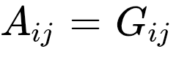 for 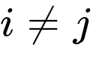 and 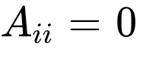) and defining the diagonal degree matrix 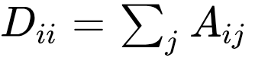, the unnormalized graph Laplacian is:

The spectral properties of  characterize the global clustering of the evidence network. The second-smallest eigenvalue of , known as the Fiedler value or algebraic connectivity 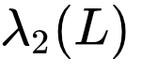, satisfies:
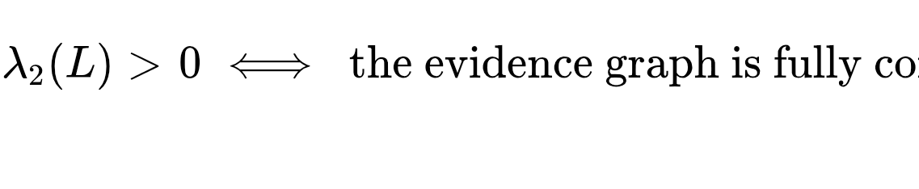
A near-zero indicates that the evidence set decomposes into disconnected or loosely tied clusters of corroboration. This graph structure resolves non-transitive dependency relationships where pairwise metrics fail (e.g., 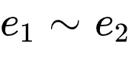 and 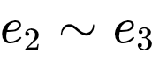, but 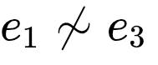).
Recent numerical simulations comparing heat-kernel Laplacian diffusion against wave dynamics on evidence graphs demonstrate distinct operational characteristics:

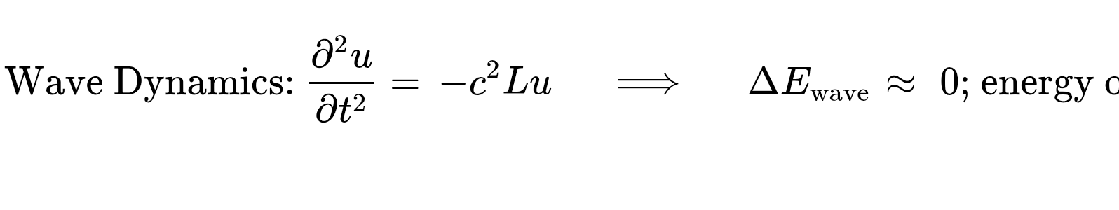
The empirical observation that heat-kernel diffusion dissipates high-frequency noise while preserving low-frequency structural components confirms its suitability for smoothing structural provenance networks without introducing spurious standing-wave oscillations.

Temporal Dynamics and Migration Semantics
In operational environments, evidence relationships evolve dynamically. A time-dependent Gram matrix 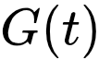 captures emerging correlations, such as multiple independent agents switching to a common upstream data feed:
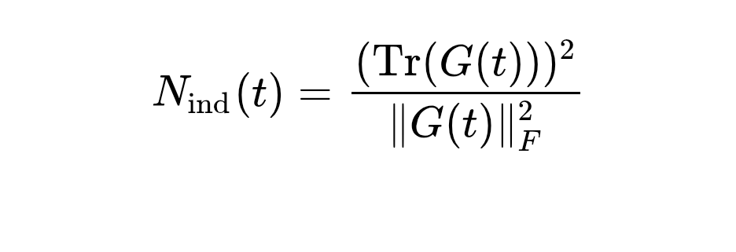
Monitoring the rate of temporal degradation 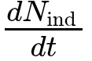 allows the EIS to detect structural anomalies. A sudden drop in signals systemic correlation events, such as automated source synchronization or coordinated adversarial spamming.
When the underlying provenance embedding schema undergoes a version migration (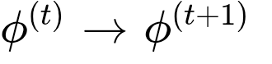), historical independence metrics lose semantic continuity. The EIS migration protocol addresses this by establishing explicit reassessment scopes:
- Full Re-indexing: Recomputing 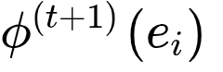 for all historical evidence items in the active memory window.
- Kernel Alignment Mapping: Estimating a transformation matrix 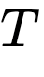 such that 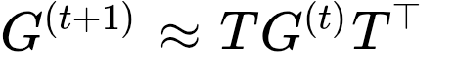.
- Audit Log Versioning: Immutable hashing of  to ensure historical trust updates remain auditable.

Bayesian Trust Updating and Robustness to Strategic Duplication
The ultimate purpose of the EIS pipeline is adjusting probabilistic updating rules to prevent overconfidence³. The inference chain is structured as:
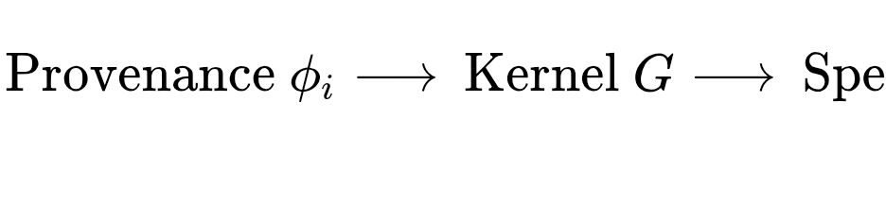
In a standard Bayesian updating scheme for a binary hypothesis 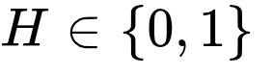, the log-odds update given independent evidence sources is additive:
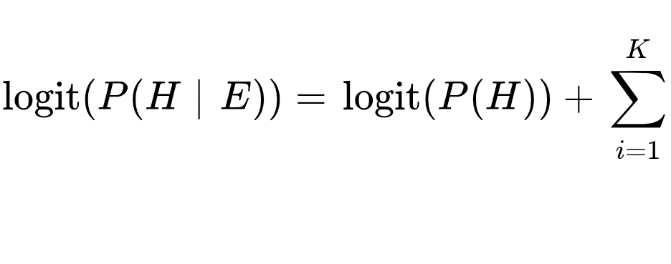
Under the EIS framework, evidence updates are adjusted using a global or source-specific discounting factor derived from the normalized effective rank²:
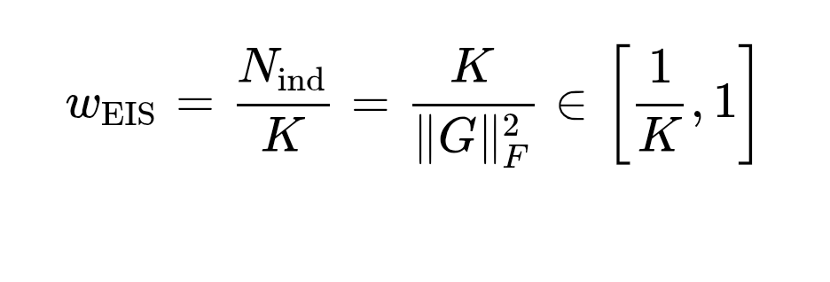
The adjusted Bayesian log-odds update becomes:
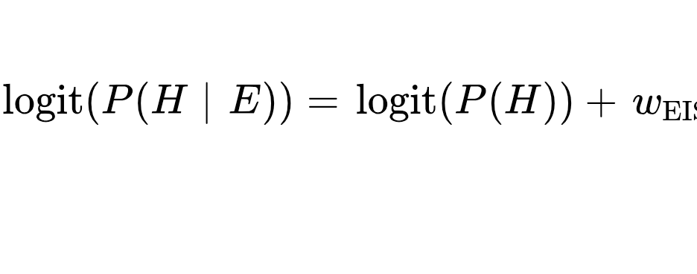
This scaling protects the inference system against adversarial "sock-puppet" attacks². In a sock-puppet scenario, an adversary generates 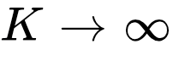 apparent observations originating from a single coordinated mechanism². Under naïve aggregation, confidence approaches certainty (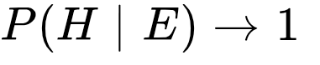). Under EIS, as with redundant sources, 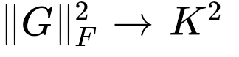, causing 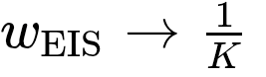. The total effective log-odds weight remains bounded:
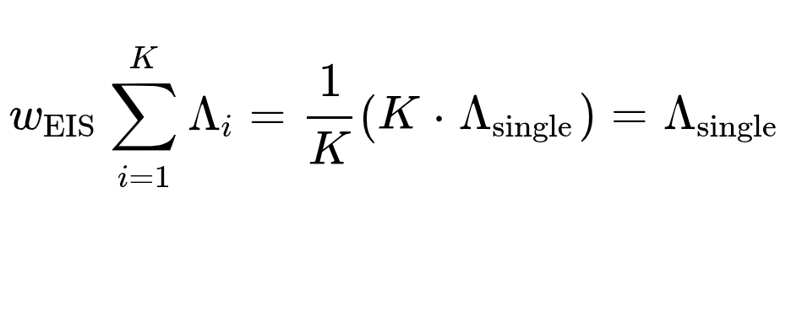
The system automatically collapses the infinite redundant observations down to the mathematical weight of a single source, neutralizing the attack².

Epistemic Classification of Current Evidence
To maintain rigorous scientific standards, the current claims of the EIS framework are categorized by their epistemic status:

Claim Description | Scientific Classification | Proof / Source Basis
Symmetry & Positivity of Kernel | Mathematically Proved | Follows directly from Mercer's theorem for RBF kernels.
Effective Rank Boundedness () | Mathematically Proved | Rigorously established via Cauchy-Schwarz and non-negative spectral mass sums.
Sock-Puppet Boundedness Limit | Mathematically Proved | Verified limit of 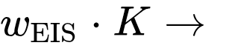 as off-diagonal kernel terms .
Spectral Rank as Information Capacity Proxy | Theoretically Supported | Dependent on the assumption that provenance feature distance maps to conditional independence¹.
Graph Diffusion Damping of High Frequencies | Empirically Corroborated | Confirmed via heat-kernel vs. wave dynamics numerical simulations ()⁶.
True Latent Source Parameter Recovery | Unproven Hypothesis | Requires execution of controlled benchmark experiments across varying latent counts .
40% Reduction in Operational False Positives | Strategic Objective | Commercial performance claim; unverified by external peer review.
80% Reduction in Manual Verification Cost | Strategic Objective | Commercial performance claim; unverified by external peer review.

Critical Issues and Open Formal Items
Before the EIS can be recognized as an established scientific specification, several critical formal issues must be resolved:
- Semantic Conflation of Rank and Probabilistic Independence: The metric measures the effective dimensionality of a linear span in Hilbert space¹. Linear independence in is necessary but insufficient for full probabilistic independence 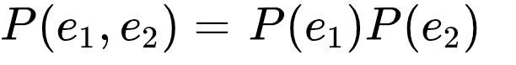. The specification must clarify this distinction to avoid semantic overreach.
- Sensitivity to Kernel Bandwidth : Because varies monotonically with , an uncalibrated bandwidth selection invalidates the metric. The EIS requires an automated parameter selection rule, such as the median heuristic:
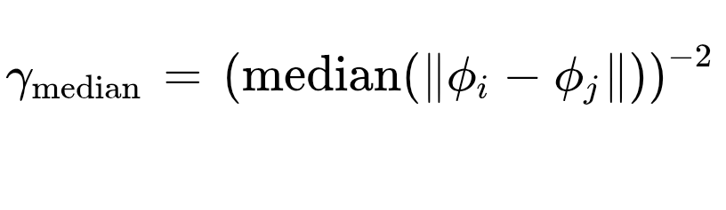
- Validation of Provenance Embeddings : The framework assumes accurately reflects structural lineage. If is noisy, incomplete, or gameable by an adversary, downstream spectral calculations will inherit those distortions.
- Sample Size Asymptotics ( vs. Dimension ): The behavior of the participation ratio when observation counts are small (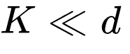) versus large (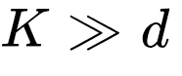) requires formal asymptotic characterization⁶.
- Adversarial Manipulation of Metadata: While EIS resists observation duplication, an adversary capable of spoofing metadata can artificially increase , causing redundant evidence to appear independent. Threat modeling for -spoofing must be integrated into the architecture.
- Integration of Algebraic Connectivity : The precise formula mapping to decision thresholds remains heuristic and requires formal standardizations.
- Restatement of Expected Information Gain (EIG): Formal derivations connecting directly to Shannon Mutual Information and EIG bounds remain open research questions.
- Reassessment Semantics under Partial Migration: Defining exact temporal backtesting bounds when updating embeddings for active real-time data streams without interrupting live inference remains an unresolved engineering item.

Comprehensive Empirical Validation Program
To transition the EIS from a prospective theoretical specification to an empirically validated framework, six core benchmark experiments must be executed:

Experiment Identifier | Experimental Methodology | Theoretical Target / Benchmark
Experiment A: Latent Source Recovery | Generate  synthetic evidence streams derived from  discrete latent processes, where . Compute . | Evaluate error 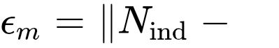. Monotonic convergence to confirms dimensionality tracking.
Experiment B: Correlation Sweep | Generate evidence streams with controlled pairwise correlation 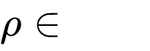. Measure 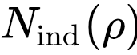. | Verify smooth, monotonic degradation from 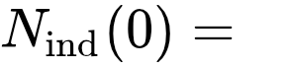 down to 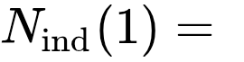.
Experiment C: Bandwidth Sensitivity | Evaluate across an extended grid sweep of . | Measure variance 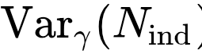 to identify stable plateau regions for robust bandwidth selection.
Experiment D: Adversarial Duplication | Inject 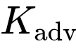 duplicate streams from a single latent source into an existing evidence set. | Verify that remains bounded () despite 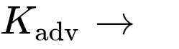².
Experiment E: Independent Control | Input streams generated by mutually orthogonal, independent noise processes. | Confirm that  and normalized score .
Experiment F: Confidence Inflation Mitigation | Compare posterior estimates under naïve updating versus EIS-adjusted updating on correlated evidence sets². | Quantify confidence inflation reduction  against ground truth priors².
All experimental executions must adhere to an immutable computational reproducibility standard, represented by the auditable function:

where  is the immutable dataset hash, represents hyperparameter sets,  is the random seed, and  defines the containerized environment manifest.

Peer-Review Verdict and Formal Recommendations

Final Review Verdict
Promising Foundational Framework — Major Revision
The theoretical foundation of the Evidence Independence Specification is technically sound, mathematically coherent, and addresses a major vulnerability in multi-source information processing². Its mathematical components—specifically the positive-semidefinite Gram matrix construction, the bounded participation-ratio effective rank, and the sock-puppet limit proofs—are fully sound¹.
However, the specification requires a major revision to eliminate semantic overreach. The score must not be presented as a direct measure of universal probabilistic statistical independence. It is properly defined as a kernel- and provenance-dependent metric of effective spectral dimensionality.

Recommended Formal Scientific Definition
For institutional publication, the EIS framework should adopt the following explicit scientific definition:
"The Evidence Independence Specification (EIS) is a mathematical specification for representing, quantifying, and operationally accounting for structural redundancy among evidence sources using provenance representations, kernel geometry, spectral effective dimensionality, graph structure, and associated uncertainty mechanisms."

Sequential Publication Pipeline
To transition the EIS into an institutionally recognized standard, the operational deployment should follow a strict sequential pipeline:

+-------------------------------------------------------------------+
| Phase 1: EIS v1.0 Formal Specification Release |
+-------------------------------------------------------------------+
|
v
+-------------------------------------------------------------------+
| Phase 2: Formal Mathematical Audit & Open-Item Resolution |
+-------------------------------------------------------------------+
|
v
+-------------------------------------------------------------------+
| Phase 3: Execution of Validation Program (Experiments A - F) |
+-------------------------------------------------------------------+
|
v
+-------------------------------------------------------------------+
| Phase 4: Independent Adversarial & Replication Audits |
+-------------------------------------------------------------------+
|
v
+-------------------------------------------------------------------+
| Phase 5: External Peer Review & Formal Release (EIS v2.0) |
+-------------------------------------------------------------------+
Commercial performance claims—including false-positive reduction rates and operational cost savings—must remain explicitly classified as strategic research goals until validated through the completion of this publication sequence. With these semantic boundaries maintained, the EIS provides a sound mathematical framework for automated evidence accounting and trust evaluation.

Obras citadas
- Data quality for the inverse lsing problem - Chimera, https://chimera.roma1.infn.it/FEDERICO/Publications_files/2016_JPA_49_384001.pdf
- HMI Ghosting: Europe's Physical-Control Blind Spot - https://debuglies.com, https://debuglies.com/2026/08/06/hmi-ghosting-europes-physical-control-blind-spot/
- Statistics - CDAC Rankers | DBDA Notes, CCEE Practice & Projects, https://cdacrankers.in/statistics
- Measures of (In)dependence Using Positive Definite Kernels - Zoltán Szabó, https://zoltansz.github.io/publications/sriperumbudur18kernel_slides.pdf
- Judea Pearl - Probabilistic Reasoning in Intelligent Systems.pdf - The Swiss Bay, https://theswissbay.ch/pdf/Gentoomen%20Library/Artificial%20Intelligence/Bayesian%20networks/Judea%20Pearl%20-%20Probabilistic%20Reasoning%20in%20Intelligent%20Systems.pdf
- Connectivity Structure and Dynamics of Nonlinear Recurrent Neural Networks - PMC - NIH, https://pmc.ncbi.nlm.nih.gov/articles/PMC12782219/
- The Entropic Bound for Transformers: Why Static Rank Fails and Attention-Native Rank Recovers - arXiv, https://arxiv.org/pdf/2607.23050
- Counterfactual Reasoning Underlies the Learning of Priors in Decision Making, https://www.researchgate.net/publication/327067025_Counterfactual_Reasoning_Underlies_the_Learning_of_Priors_in_Decision_Making
- Same Architecture, Different Capacity: Optimizer-Induced Spectral Scaling Laws - arXiv, https://arxiv.org/pdf/2605.21803
- Information-Theoretic Unsupervised Embedding Quality Evaluation - OpenReview, https://openreview.net/pdf?id=EwaNoLlEXT
- Measuring Statistical Dependence with Hilbert-Schmidt Norms - Gatsby Computational Neuroscience Unit, http://www.gatsby.ucl.ac.uk/~gretton/papers/GreBouSmoSch05.pdf
- HiSVD: Principled Low-Rank Approximation of LLMs via Hierarchical Modeling of Information Capacity and Spectral Structure - ACL Anthology, https://aclanthology.org/2026.acl-long.946.pdf

